Get familiar with GitHub

Submit screenshots for the completion of all the following GitHub Skills

1. <https://github.com/skills/introduction-to-github>
2. <https://github.com/skills/communicate-using-markdown>

Your screenshot should reflect successful completion of the above labs.

Also, complete the following task:

• Create a Public GitHub Repository with the name “Test-Cloud-Infrastructure”

• Make sure to include ReadMe file in your repository.

• Push the PDF of the course syllabus to the repository.

• In a separate commit and push, delete the PDF file of the course syllabus

• Push the PDF of the homework PDF to your public repository.

• Submit the following:

a) A screenshot of your GitHub repository history

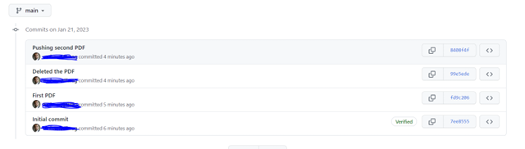

b) A screenshot of current view of your repository (sample screenshot is

shown below – using different file)

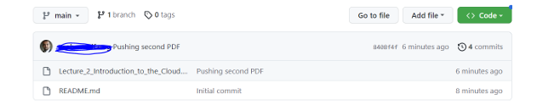

c) The URL of your public repository